**TWO POSSIBLE CONFIGURATIONS FOR GSDR VAC ANS CW SKIMMER**

* 2 VAC cables only.
* PC sound card (IDT Hi def+MME) + One VAC cable

**GSDR CONFIGS COMMON TO BOTH SOLUTIONS:**

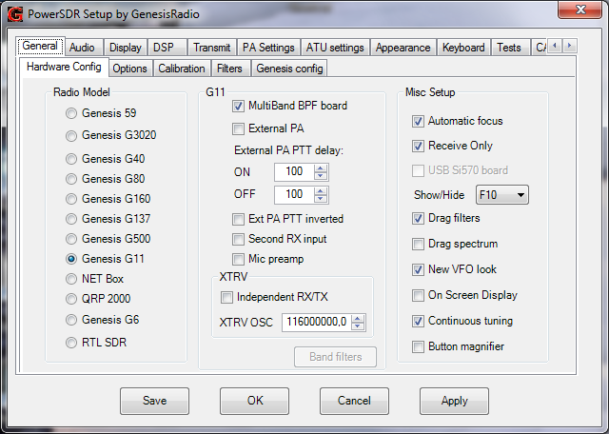

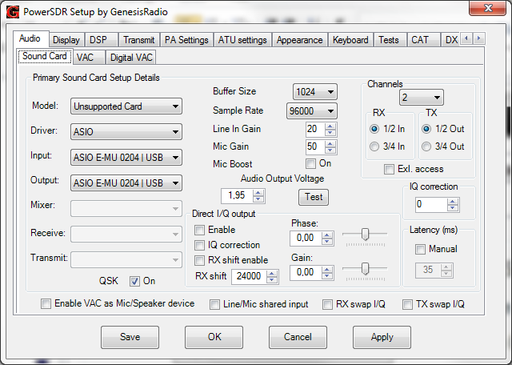

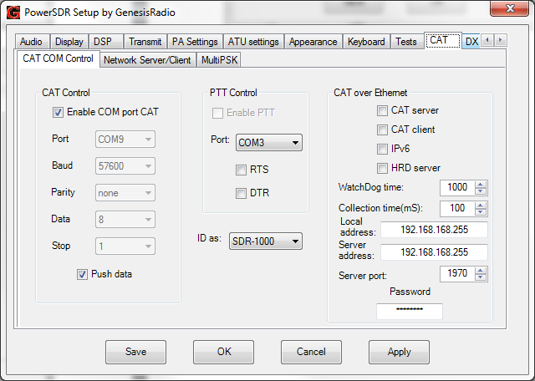

**VAC PANEL CONFIGURATION**

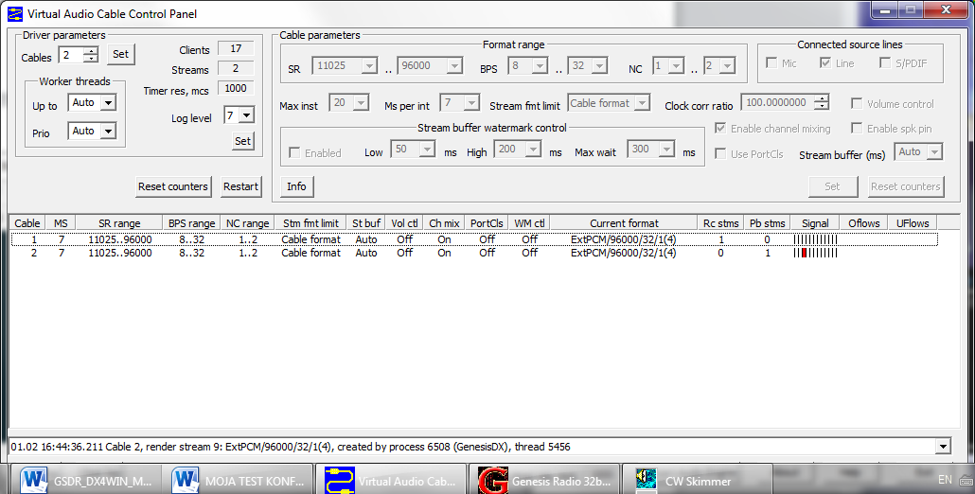

**TWO VAC CABLE CONFIG PROPOSED BY FLEX RADIO**

**WDM-KS works with lower latency than MME (change latency if popping)**

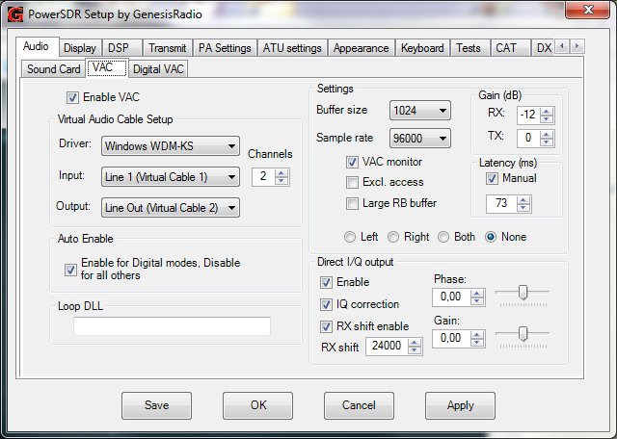

Problem w. above: whole GSDR frequency display moves with mouse freq. choices when RX shift enabled (LO changes with frequency).

**Frequencies must be selected only by clicking on Skimmer waterfall display or decoded calls.**

**CW Skimmer setups with 2 VAC cables**

|  |  |
| --- | --- |
|  |  |
|  |  |

Remarx: GSDR CAT com9 connected to DDUtil com19 via virtual data cable

**Attention: if after a click to a station on Skimmer waterfall the station signals/call is not seen/heard within the green cursor, reverse the I/Q value in the Audio setting of the Skimmer!**

Skimmer is connected to DDUtil RCP2 via com 13<->com14 virtual data cable

**CW SKIMMER ACTIVATED**

**Curved pattern comes from evaluation VAC version (voice reminding message); disappeared after installation of registered version of VAC**

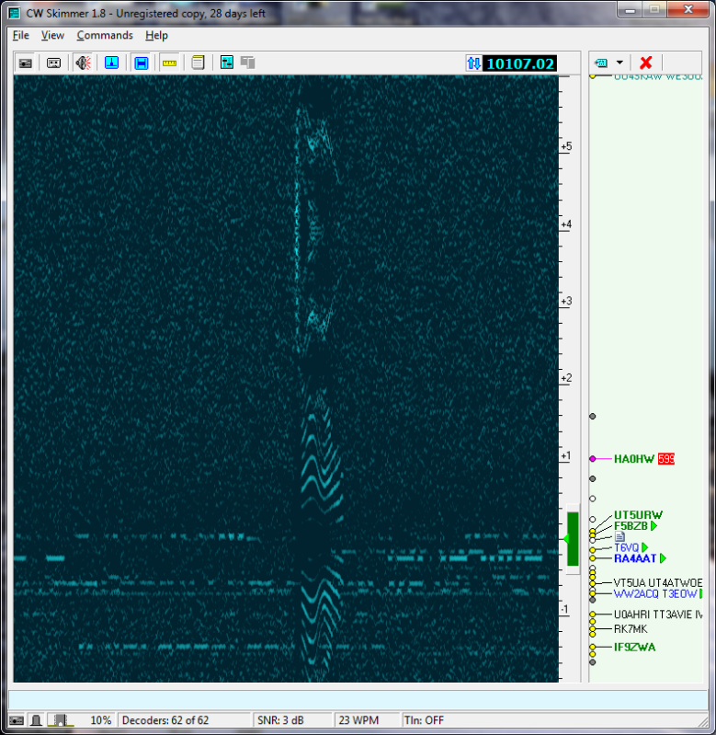

**After installing registered version of VAC (no more voice message interference)**

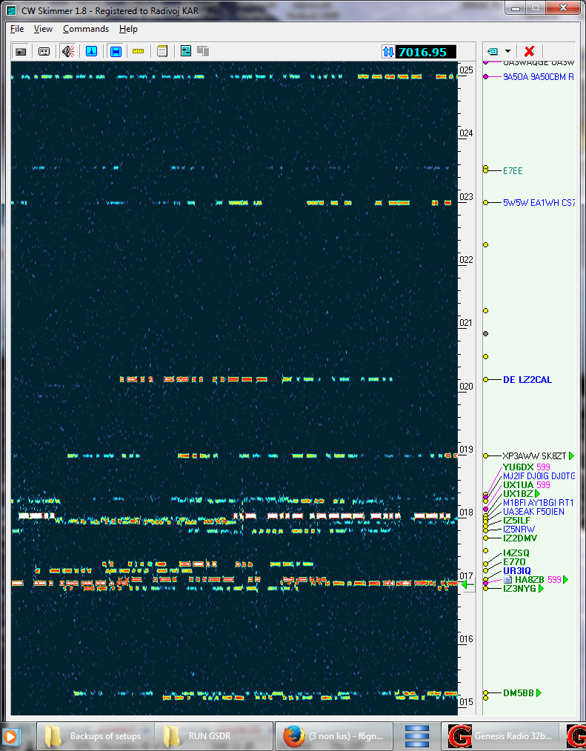

**GSDR WINDOW SHOWING SAME FREQUENCY ON WHICH SKIMMER WAS TUNED TO**

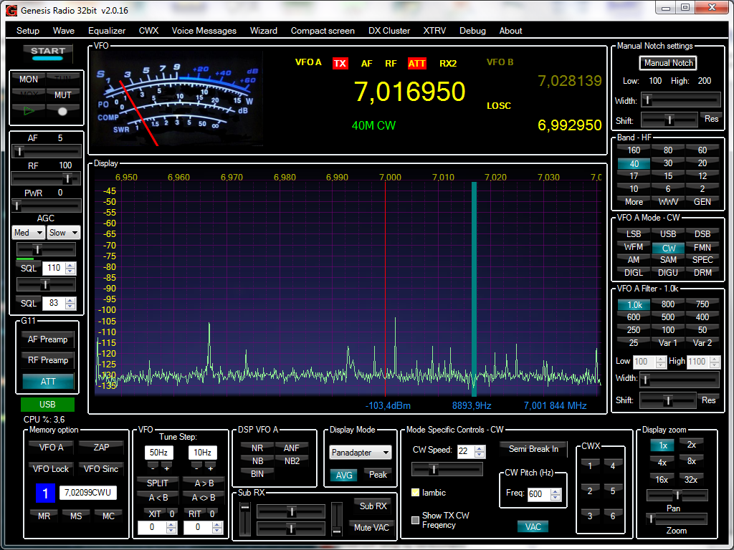

**SYSTEM USING PC SOUNDCARD AND 1 VAC CABLE**

**PROPOSED BY Goran YT7PWR**

Works fine, Skimmer indicates correct frequencies, but on GSDR screen still moving frequency display due to variation of LO with frequency selection.. **Frequencies must be selected only by clicking on Skimmer waterfall display or on decoded calls.**

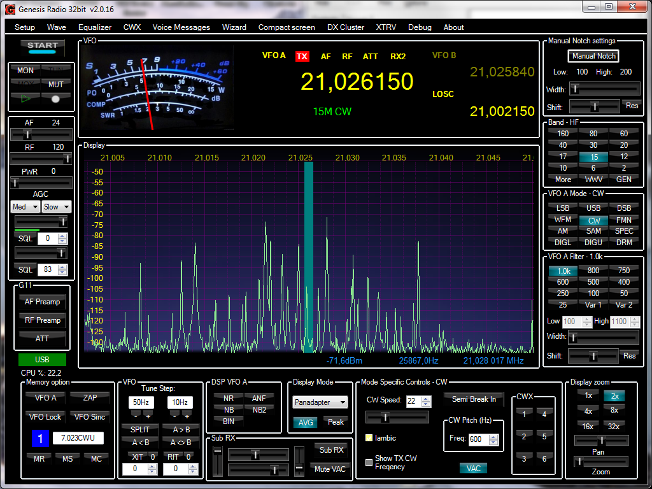

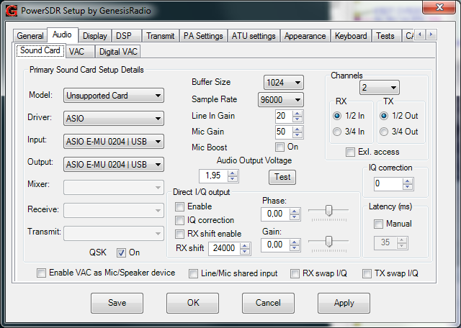

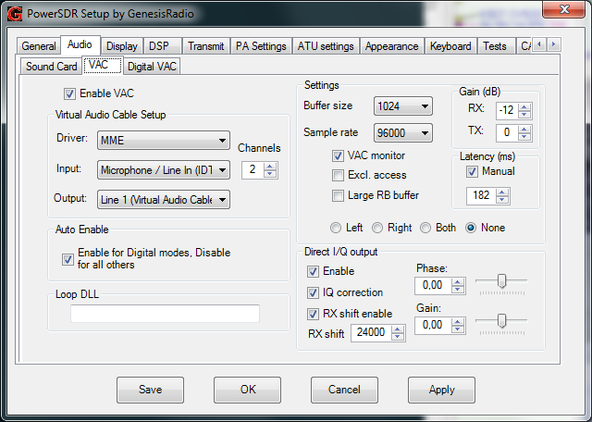

Above: RX shift enabled causes moving frequency display on GSDR**. Use Skimmer to select frequencies/stns**.

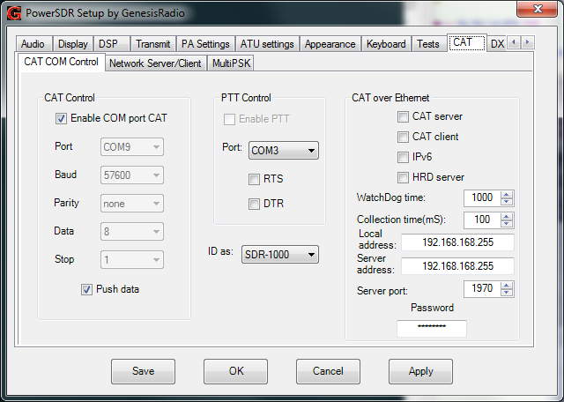

**SKIMMER SETUP**

|  |  |
| --- | --- |
|  |  |
|  |  |

**Attention: if after a click to a station on Skimmer waterfall the station signals/call is not seen/heard within the green cursor, reverse the I/Q value in the Audio setting of the Skimmer!**

Remarx: GSDR CAT com9 connected to DDUtil com19 via virtual data cable

Skimmer connected to DDUtil RCP2 via com 13<->com14 virtual data cable

**CW Skimmer full span = selected frequency +/- 12 kHz**

(sensitivity drops at edges due to Skimmer filter).

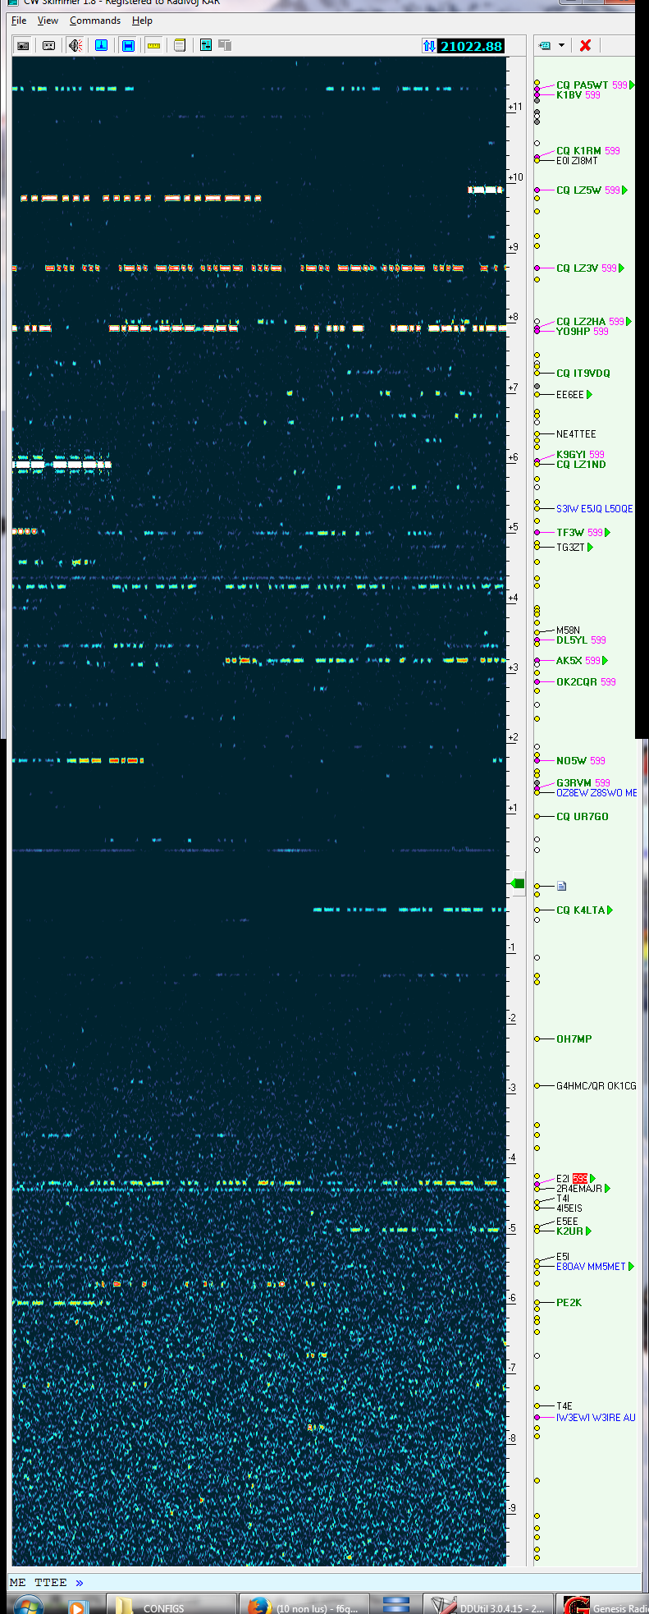

**Problem:** If I want to set QSX frequency for TX split, I lose listening of DX-ped's frequency. This becomes even more complicated when the QSX is far above the 12 kHz  off-VFO limit of the Skimmer.

Possible solution: select SPLIT on GSDR , click MS (memory save) to save DX-ped freq, jump to Skimmer, with PC PgUP and mouse click on waterfall, select TX Split frequency, which will appear in GSDR as vfoA frequency, then select A>B to transfer this frequency to TX (vfo B), then click on MR (memory return) to continue listening DX station and transmitt on a new Split frequency. (Must use VFO MEM instead of freq swap A<>B as with some large RX/TX differences swap risks to result in both frequencies identical, even with “VFO B extended” is checked in GSDR).

To select new QSX frequency, click on Skimmer Waterfall and again on MR to receive DX freq. In this solution listening to DX-ped frequency is stil performed via G11/GSDR…

**DDUTIL CONFIGURATION**

|  |
| --- |
|  |
|  |

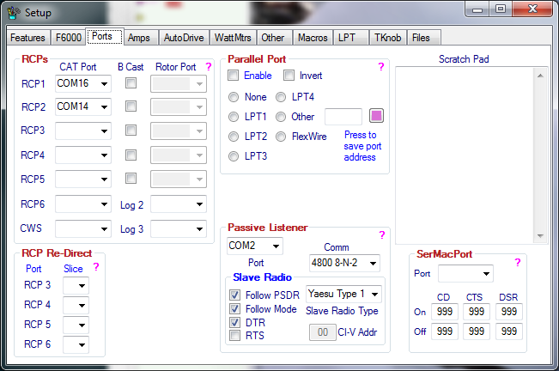

**CONCLUSION**

After all trials and head kicking, I think the only viable solution would be to **drop listening on SDR**, leave SDR only for Skimmer, and do RX and TX on FT1000MP, with SPLIT button activated. This will allow for QSX beyond the +12 kHz limit of the Skimmer:

**Simple and fast solution**:

With SPLIT activated on FT1000MP, listen to DX-ped frequency on sub-RX vfo-B, transmit on vfo-A. For better CW selectivity install optional 500Hz CW filter YF-115C for sub-RX.

**To listen to DX-ped on better performing main RX (vfo-A):**

Spot DX-ped on Skimmer and click , it will select vfo-A on MP. Then press STO (under QMB) and select QSX frequency on Skimmer, which will be synced to vfo-A. Then press A>B and RCL (under QMB), to continue listening to DX on vfo-A and transmit on QSX vfo-B.

Next QSX goes to vfo-A, A>B + RCL , and so on...

**Ideal solution:** modify DDUtil program to allow selection of vfo-A or vfo-B for Slave Radio. This would allow for listening on main RX and automatic selection of vfo-B via Skimmer!